B-SAFE User Guide
Upon opening the B-SAFE Tool, users are directed to the User Input worksheet. The left side of the sheet shows criteria to use for filtering agents.
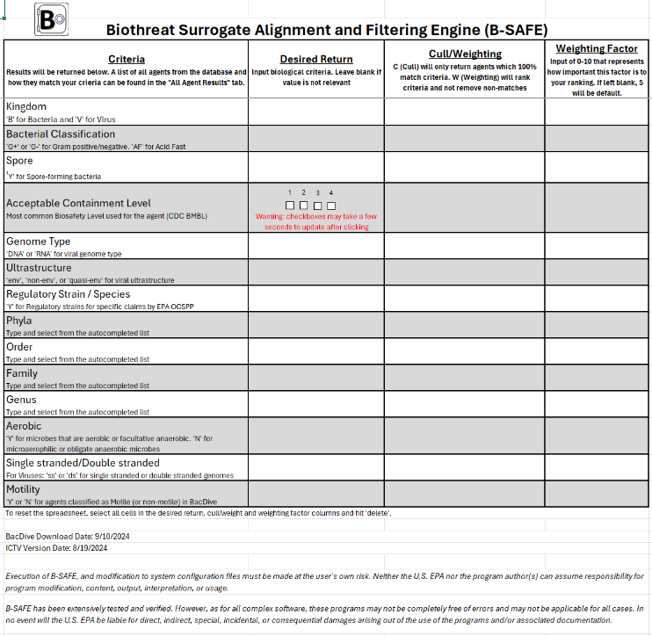

The right side of the sheet shows filtered results. Without any filter criteria, all agents will be listed but will only list “#DIV/0!” in the Total field, as there is not any weighting criteria.
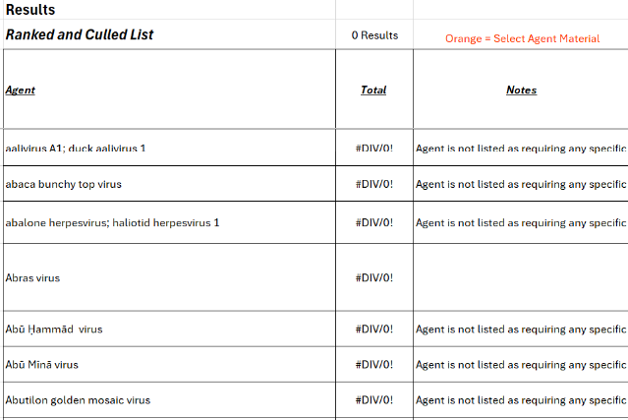

Below is a summary of how user-specified entries are applied.
- Desired Return: allows users to specify filtering criteria.
- Cull/Weighting: By default, the field is blank (equivalent to “W”). This means that Agents will not be removed if they do not match user specifications. Instead, agents will be weighted to indicate best match. Specifying “C” removes Results that do not match all of the specifications.
- Weighting Factor: By default, the field is blank (equivalent to “5”). This would assign the same importance to each filter criteria. Entries of 0-10 can be used to assign varying levels of importance to each filter criteria.
Below is a user specification example. In this case, the user requires a spore forming bacteria, so those criteria are chosen to cull. The user is interested in a surrogate for anthracis that they can safely work with in a BSL-2 or lower facility. The user knows that their ideal surrogate will be a BSL1 or BSL2, spore-forming bacteria that is gram positive and aerobic. These criteria can be assigned weights based on necessity and preference. For example, necessary criteria are bacteria and spore, thus “C” has been input in the Cull/Weight column. Acceptable Containment Level of 1 or 2 is also necessary. To indicate the importance of Acceptable Containment Level the criteria can either be selected as a “C”, or maximum weighing can be applied like in this example where 10 is input in the Weighing factor column. Gram positive and aerobic are ideal but not necessary, so weighing factor has been left blank (equivalent to 5).
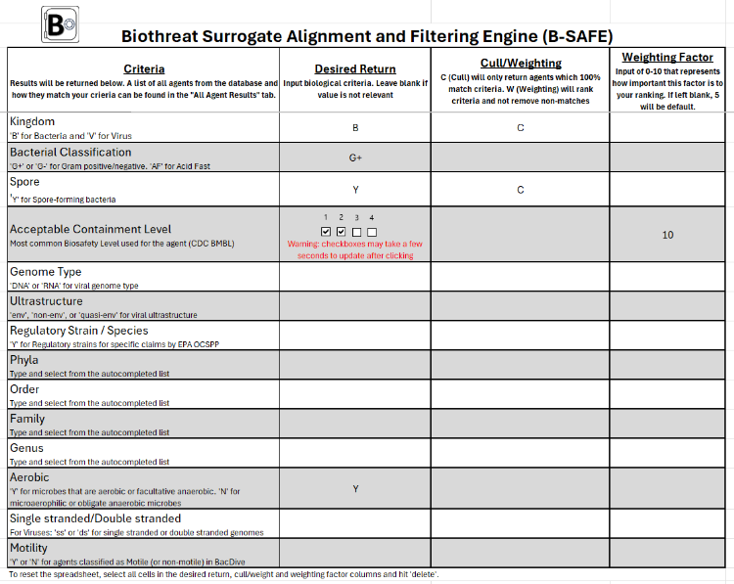

Results for each search are displayed in two ways. The first is shown in the “User Input” tab. This is a culled list of agents and is ranked and alphabetized based on weighted (non-culled) categories. A total number of results is shown as well as the percent match to the selected criteria. In this example, the user has a total of 645 results.

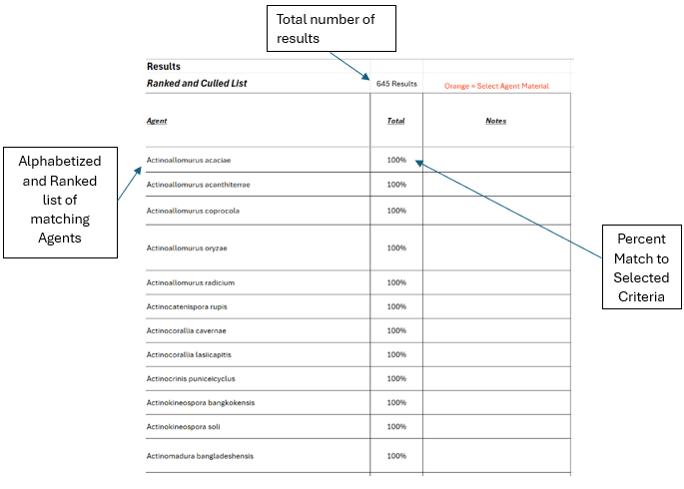

The second results view is available in the “All Agent Results” worksheet. This table shows all the agents in the database and their matching criteria. Black cells show criterion where a match is available. White cells are unmatched criteria and grey cells are criteria that were not utilized in the calculation. The percentages reflect the weight each criterion was given to calculate the total percent match. This results view allows the user to see the full range of options available in the tool and potentially assess why an expected result was not returned.
